Бородина Анастасия Владимировна, группа 2207д2.
1. ERD-диаграмма: БД
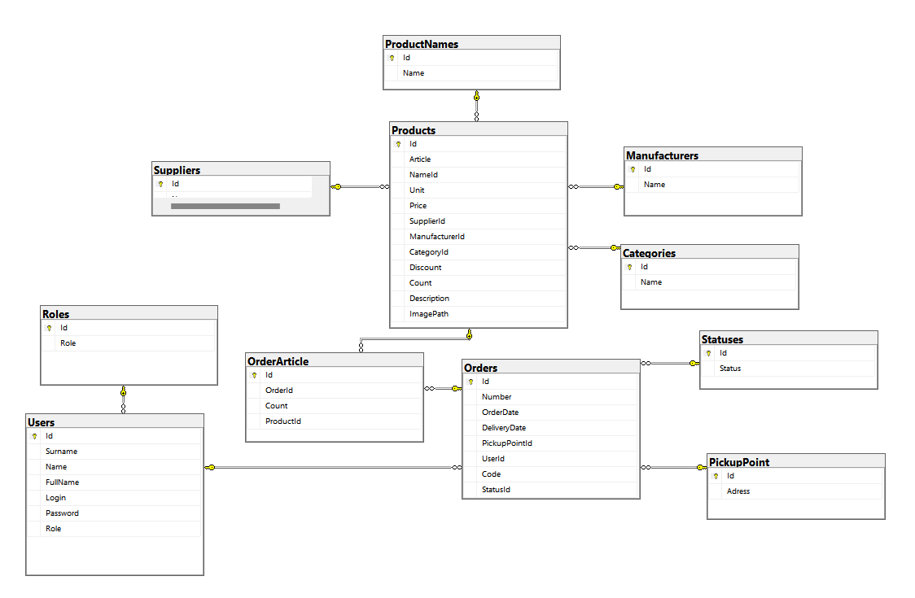

2. Cкрипт создания БД
USE [BorodinaAV_2207d2]
GO
/****** Object: Table [dbo].[Categories] Script Date: 19.04.2026 20:55:40 ******/
SET ANSI_NULLS ON
GO
SET QUOTED_IDENTIFIER ON
GO
CREATE TABLE [dbo].[Categories](
[Id] [int] NOT NULL,
[Name] [nvarchar](255) NULL,
CONSTRAINT [PK__Categori__3214EC07467E0091] PRIMARY KEY CLUSTERED
(
[Id] ASC
)WITH (PAD_INDEX = OFF, STATISTICS_NORECOMPUTE = OFF, IGNORE_DUP_KEY = OFF, ALLOW_ROW_LOCKS = ON, ALLOW_PAGE_LOCKS = ON) ON [PRIMARY]
) ON [PRIMARY]
GO
/****** Object: Table [dbo].[Manufacturers] Script Date: 19.04.2026 20:55:40 ******/
SET ANSI_NULLS ON
GO
SET QUOTED_IDENTIFIER ON
GO
CREATE TABLE [dbo].[Manufacturers](
[Id] [int] NOT NULL,
[Name] [nvarchar](255) NULL,
CONSTRAINT [PK__Manufact__3214EC07F7ADCC76] PRIMARY KEY CLUSTERED
(
[Id] ASC
)WITH (PAD_INDEX = OFF, STATISTICS_NORECOMPUTE = OFF, IGNORE_DUP_KEY = OFF, ALLOW_ROW_LOCKS = ON, ALLOW_PAGE_LOCKS = ON) ON [PRIMARY]
) ON [PRIMARY]
GO
/****** Object: Table [dbo].[OrderArticle] Script Date: 19.04.2026 20:55:40 ******/
SET ANSI_NULLS ON
GO
SET QUOTED_IDENTIFIER ON
GO
CREATE TABLE [dbo].[OrderArticle](
[Id] [int] NOT NULL,
[OrderId] [int] NULL,
[Count] [float] NULL,
[ProductId] [int] NULL,
CONSTRAINT [PK__OrderArt__3214EC07A1076A14] PRIMARY KEY CLUSTERED
(
[Id] ASC
)WITH (PAD_INDEX = OFF, STATISTICS_NORECOMPUTE = OFF, IGNORE_DUP_KEY = OFF, ALLOW_ROW_LOCKS = ON, ALLOW_PAGE_LOCKS = ON) ON [PRIMARY]
) ON [PRIMARY]
GO
/****** Object: Table [dbo].[Orders] Script Date: 19.04.2026 20:55:40 ******/
SET ANSI_NULLS ON
GO
SET QUOTED_IDENTIFIER ON
GO
CREATE TABLE [dbo].[Orders](
[Id] [int] NOT NULL,
[Number] [float] NULL,
[OrderDate] [datetime] NULL,
[DeliveryDate] [datetime] NULL,
[PickupPointId] [int] NULL,
[UserId] [int] NULL,
[Code] [float] NULL,
[StatusId] [int] NULL,
CONSTRAINT [PK__Orders__3214EC074E32F187] PRIMARY KEY CLUSTERED
(
[Id] ASC
)WITH (PAD_INDEX = OFF, STATISTICS_NORECOMPUTE = OFF, IGNORE_DUP_KEY = OFF, ALLOW_ROW_LOCKS = ON, ALLOW_PAGE_LOCKS = ON) ON [PRIMARY]
) ON [PRIMARY]
GO
/****** Object: Table [dbo].[PickupPoint] Script Date: 19.04.2026 20:55:40 ******/
SET ANSI_NULLS ON
GO
SET QUOTED_IDENTIFIER ON
GO
CREATE TABLE [dbo].[PickupPoint](
[Id] [int] NOT NULL,
[Adress] [nvarchar](255) NULL,
CONSTRAINT [PK__PickupPo__3214EC07B4D766BD] PRIMARY KEY CLUSTERED
(
[Id] ASC
)WITH (PAD_INDEX = OFF, STATISTICS_NORECOMPUTE = OFF, IGNORE_DUP_KEY = OFF, ALLOW_ROW_LOCKS = ON, ALLOW_PAGE_LOCKS = ON) ON [PRIMARY]
) ON [PRIMARY]
GO
/****** Object: Table [dbo].[ProductNames] Script Date: 19.04.2026 20:55:40 ******/
SET ANSI_NULLS ON
GO
SET QUOTED_IDENTIFIER ON
GO
CREATE TABLE [dbo].[ProductNames](
[Id] [int] NOT NULL,
[Name] [nvarchar](255) NULL,
CONSTRAINT [PK__ProductN__3214EC0716EC5506] PRIMARY KEY CLUSTERED
(
[Id] ASC
)WITH (PAD_INDEX = OFF, STATISTICS_NORECOMPUTE = OFF, IGNORE_DUP_KEY = OFF, ALLOW_ROW_LOCKS = ON, ALLOW_PAGE_LOCKS = ON) ON [PRIMARY]
) ON [PRIMARY]
GO
/****** Object: Table [dbo].[Products] Script Date: 19.04.2026 20:55:40 ******/
SET ANSI_NULLS ON
GO
SET QUOTED_IDENTIFIER ON
GO
CREATE TABLE [dbo].[Products](
[Id] [int] NOT NULL,
[Article] [nvarchar](255) NULL,
[NameId] [int] NULL,
[Unit] [nvarchar](255) NULL,
[Price] [float] NULL,
[SupplierId] [int] NULL,
[ManufacturerId] [int] NULL,
[CategoryId] [int] NULL,
[Discount] [float] NULL,
[Count] [float] NULL,
[Description] [nvarchar](255) NULL,
[ImagePath] [nvarchar](255) NULL,
CONSTRAINT [PK__Products__3214EC076799F098] PRIMARY KEY CLUSTERED
(
[Id] ASC
)WITH (PAD_INDEX = OFF, STATISTICS_NORECOMPUTE = OFF, IGNORE_DUP_KEY = OFF, ALLOW_ROW_LOCKS = ON, ALLOW_PAGE_LOCKS = ON) ON [PRIMARY]
) ON [PRIMARY]
GO
/****** Object: Table [dbo].[Roles] Script Date: 19.04.2026 20:55:40 ******/
SET ANSI_NULLS ON
GO
SET QUOTED_IDENTIFIER ON
GO
CREATE TABLE [dbo].[Roles](
[Id] [int] NOT NULL,
[Role] [nvarchar](255) NULL,
CONSTRAINT [PK__Roles__3214EC0793EA9101] PRIMARY KEY CLUSTERED
(
[Id] ASC
)WITH (PAD_INDEX = OFF, STATISTICS_NORECOMPUTE = OFF, IGNORE_DUP_KEY = OFF, ALLOW_ROW_LOCKS = ON, ALLOW_PAGE_LOCKS = ON) ON [PRIMARY]
) ON [PRIMARY]
GO
/****** Object: Table [dbo].[Statuses] Script Date: 19.04.2026 20:55:40 ******/
SET ANSI_NULLS ON
GO
SET QUOTED_IDENTIFIER ON
GO
CREATE TABLE [dbo].[Statuses](
[Id] [int] NOT NULL,
[Status] [nvarchar](255) NULL,
CONSTRAINT [PK__Statuses__3214EC07667AC2DD] PRIMARY KEY CLUSTERED
(
[Id] ASC
)WITH (PAD_INDEX = OFF, STATISTICS_NORECOMPUTE = OFF, IGNORE_DUP_KEY = OFF, ALLOW_ROW_LOCKS = ON, ALLOW_PAGE_LOCKS = ON) ON [PRIMARY]
) ON [PRIMARY]
GO
/****** Object: Table [dbo].[Suppliers] Script Date: 19.04.2026 20:55:40 ******/
SET ANSI_NULLS ON
GO
SET QUOTED_IDENTIFIER ON
GO
CREATE TABLE [dbo].[Suppliers](
[Id] [int] NOT NULL,
[Name] [nvarchar](255) NULL,
CONSTRAINT [PK__Supplier__3214EC07818E0803] PRIMARY KEY CLUSTERED
(
[Id] ASC
)WITH (PAD_INDEX = OFF, STATISTICS_NORECOMPUTE = OFF, IGNORE_DUP_KEY = OFF, ALLOW_ROW_LOCKS = ON, ALLOW_PAGE_LOCKS = ON) ON [PRIMARY]
) ON [PRIMARY]
GO
/****** Object: Table [dbo].[Users] Script Date: 19.04.2026 20:55:40 ******/
SET ANSI_NULLS ON
GO
SET QUOTED_IDENTIFIER ON
GO
CREATE TABLE [dbo].[Users](
[Id] [int] NOT NULL,
[FullName] [nvarchar](255) NULL,
[Login] [nvarchar](255) NULL,
[Password] [nvarchar](255) NULL,
[Role] [int] NULL,
CONSTRAINT [PK__Users__3214EC0777ADA342] PRIMARY KEY CLUSTERED
(
[Id] ASC
)WITH (PAD_INDEX = OFF, STATISTICS_NORECOMPUTE = OFF, IGNORE_DUP_KEY = OFF, ALLOW_ROW_LOCKS = ON, ALLOW_PAGE_LOCKS = ON) ON [PRIMARY]
) ON [PRIMARY]
GO
ALTER TABLE [dbo].[OrderArticle] WITH CHECK ADD CONSTRAINT [FK_OrdersArticle_Orders] FOREIGN KEY([OrderId])
REFERENCES [dbo].[Orders] ([Id])
GO
ALTER TABLE [dbo].[OrderArticle] CHECK CONSTRAINT [FK_OrdersArticle_Orders]
GO
ALTER TABLE [dbo].[OrderArticle] WITH CHECK ADD CONSTRAINT [FK_OrdersArticle_Products] FOREIGN KEY([ProductId])
REFERENCES [dbo].[Products] ([Id])
GO
ALTER TABLE [dbo].[OrderArticle] CHECK CONSTRAINT [FK_OrdersArticle_Products]
GO
ALTER TABLE [dbo].[Orders] WITH CHECK ADD CONSTRAINT [FK_Orders_PickupPoints] FOREIGN KEY([PickupPointId])
REFERENCES [dbo].[PickupPoint] ([Id])
GO
ALTER TABLE [dbo].[Orders] CHECK CONSTRAINT [FK_Orders_PickupPoints]
GO
ALTER TABLE [dbo].[Orders] WITH CHECK ADD CONSTRAINT [FK_Orders_Statuses] FOREIGN KEY([StatusId])
REFERENCES [dbo].[Statuses] ([Id])
GO
ALTER TABLE [dbo].[Orders] CHECK CONSTRAINT [FK_Orders_Statuses]
GO
ALTER TABLE [dbo].[Orders] WITH CHECK ADD CONSTRAINT [FK_Orders_Users] FOREIGN KEY([UserId])
REFERENCES [dbo].[Users] ([Id])
GO
ALTER TABLE [dbo].[Orders] CHECK CONSTRAINT [FK_Orders_Users]
GO
ALTER TABLE [dbo].[Products] WITH CHECK ADD CONSTRAINT [FK_Products_Categories] FOREIGN KEY([CategoryId])
REFERENCES [dbo].[Categories] ([Id])
GO
ALTER TABLE [dbo].[Products] CHECK CONSTRAINT [FK_Products_Categories]
GO
ALTER TABLE [dbo].[Products] WITH CHECK ADD CONSTRAINT [FK_Products_Manufacturers] FOREIGN KEY([ManufacturerId])
REFERENCES [dbo].[Manufacturers] ([Id])
GO
ALTER TABLE [dbo].[Products] CHECK CONSTRAINT [FK_Products_Manufacturers]
GO
ALTER TABLE [dbo].[Products] WITH CHECK ADD CONSTRAINT [FK_Products_ProductNames] FOREIGN KEY([NameId])
REFERENCES [dbo].[ProductNames] ([Id])
GO
ALTER TABLE [dbo].[Products] CHECK CONSTRAINT [FK_Products_ProductNames]
GO
ALTER TABLE [dbo].[Products] WITH CHECK ADD CONSTRAINT [FK_Products_Suppliers] FOREIGN KEY([SupplierId])
REFERENCES [dbo].[Suppliers] ([Id])
GO
ALTER TABLE [dbo].[Products] CHECK CONSTRAINT [FK_Products_Suppliers]
GO
ALTER TABLE [dbo].[Users] WITH CHECK ADD CONSTRAINT [FK_Users_UserRoles] FOREIGN KEY([Role])
REFERENCES [dbo].[Roles] ([Id])
GO
ALTER TABLE [dbo].[Users] CHECK CONSTRAINT [FK_Users_UserRoles]
GO
3. Cкриншоты окон
сама
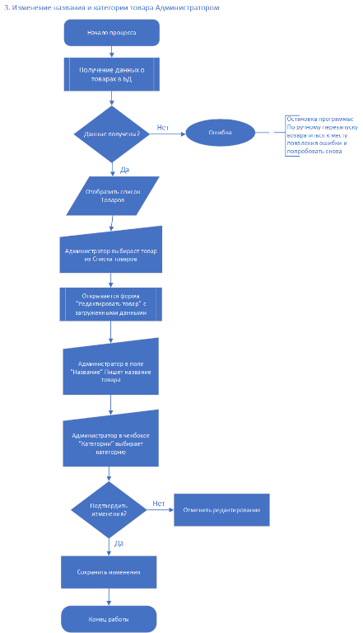
4. ERD-диаграмма: Алгоритм входа

